 | 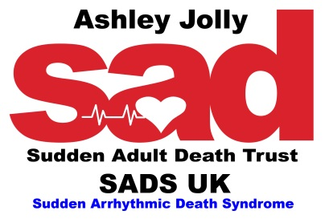 | 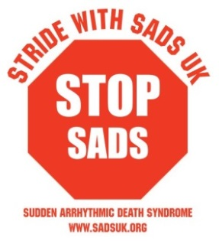

Stride with SADS UK to STOP SADS Registration Form
Sunday 13th September 2020 – Hyde Park, London
A day to unite in our common aim to STOP SADS
#stridewithsadsuk #STOPSADS
(Please see key information for event day details)

Please complete and return the registration form so we are able to send you your free STOP SADS t-shirt,
fundraising pack and a link to set you up with your SADS UK Just Giving page.
£20 per person registration fee (non-refundable)

Under 16yrs of age are free of charge and can be provided with a SADS UK iron on logo transfer to place on their own t-shirt.

Full Name | Email address | Tick if under 16yrs old | Phone

Next of Kin | Name: | Phone:

I will be walking the distance below around the Serpentine in London’s Hyde Park to STOP SADS

Please tick | One circuit = 2 Miles |  | Two Circuits = 4 Miles |  | Three circuits = 6 miles

T-shirt Size required | Extra Large | Large | Medium | Small | 16yrs old or younger –  SADS UK transfer provided

Address:-………………………………………………………………………………………………………………………………………………………………………

……………………………………………………………………………………………………………………………………………………………………………………..

- Cheques should be made payable to SADS UK and sent to the address below with surname(s) of participants taking part written on the reverse of the cheque.

- BACS Transfer can also be made. Please use a double S prior to your surname as the BACS reference so that we may identify your payment with your entry form: for example - SSJones or SSBrown.

- Please also email the charity at sadsuk@btconnect.com to advise you have made payment to enable your registration form to be linked to your payment and we can confirm safe receipt of payment to you.

BACS details – Bank Name: SADS UK Bank Account no: 77056965 Sort Code: 60 03 25

By registering for the event I agree to SADS UK taking photos and using images of myself and family*(* if applicable) in the media. I understand that children taking part who are under 18yrs old must be accompanied by an adult.

I understand that people taking part in the event do so at their own risk and accept responsibility for themselves and any dependents on the day.

Signed…………………………………………Printed…………………………………………………………….……Date……………………………..…………..
Closing Date for registration for the Stride with SADS UK to STOP SADS event is 31st July 2020

Funds raised from the Stride with SADS UK to STOP SADS event will go directly to charity funding
to help SADS UK continue in their aims and objectives to save lives as outlined in the SADS UK Manifesto

SADS UK Suite 7, Churchill House, Horndon Park, West Horndon, Essex CM13 3XD

Tel: 01277 811215 Email:sadsuk@btconnect.com

